Please use VHF Channel 10 for communication before and during the boat parade.
Boat parade begins at 2 PM Sunday, March 29th
Awards/Closing Ceremonies at 4 PM Sunday, March 29th on waterfront stage.
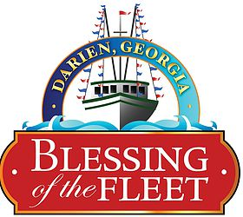

52nd Annual Blessing of the Fleet Shrimp Boat Parade
Sunday, March 29, 2020 at the Darien Waterfront
Please fill out fully
Vessel Name_______________________________________________________________
Home Dock Location _________________________________________________________
Length_______ Engine type________________________________ Horsepower_________
Check one: Twin Screw_______ or Single Screw_______ Vessel Draft__________
Vessel Builder__________________________________________ Year Built ____________
Vessel Builder Location________________________________________________________

Owner’s Name_______________________________________________________________
Owner’s Mailing Address_______________________________________________________
Owner’s Phone Number________________________________________________________
Owner’s Email Address_________________________________________________________

Captain’s Name_______________________________________________________________
Captain’s Mailing Address_______________________________________________________
Captain’s Phone Number________________________________________________________
Captain’s Email Address_________________________________________________________

Page 1 of 2

How long has the captain been captaining a shrimp boat?
____________________________________________________________________________ What is the farthest the captain has shrimped from McIntosh County?
____________________________________________________________________________

What is the meaning behind your boat’s name?
____________________________________________________________________________ ____________________________________________________________________________ ____________________________________________________________________________
____________________________________________________________________________
What generation is the captain and owner in the shrimping industry?
Captain ______________________________________________________________________
Owner_______________________________________________________________________
Is the vessel used for the commercial catching of other products (such as jelly balls, conchs, etc.)? If yes, then say what products_______________________________________________
Please list any other interesting information below:
______________________________________________________________________________ ______________________________________________________________________________
______________________________________________________________________________
______________________________________________________________________________ ______________________________________________________________________________
______________________________________________________________________________
______________________________________________________________________________
______________________________________________________________________________
______________________________________________________________________________
Page 2 of 2

